
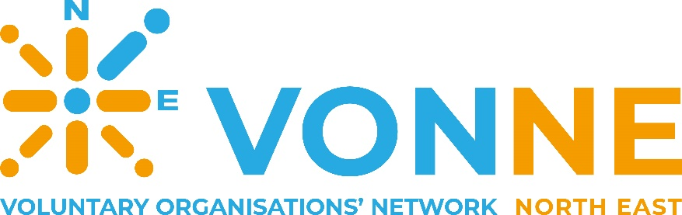

Chair of VONNE
Recruitment Pack

June 2026



Contents

Welcome from VONNE’s Vice Chair
Who is VONNE? 5
What does VONNE do? 5
How does VONNE do this? 5
Why does VONNE do this? 5
Meet the VONNE Team 8
VONNE Board of Trustees 8
VONNE Senior Management Team 8
What our Trustees do 9
Chair of VONNE 10
What we're looking for 10
Key responsibilities 10
Skills, experience and personal qualities 10
How to apply 12
Recruitment Timetable 12
How we will use your information 12
Application Form and declaration 13
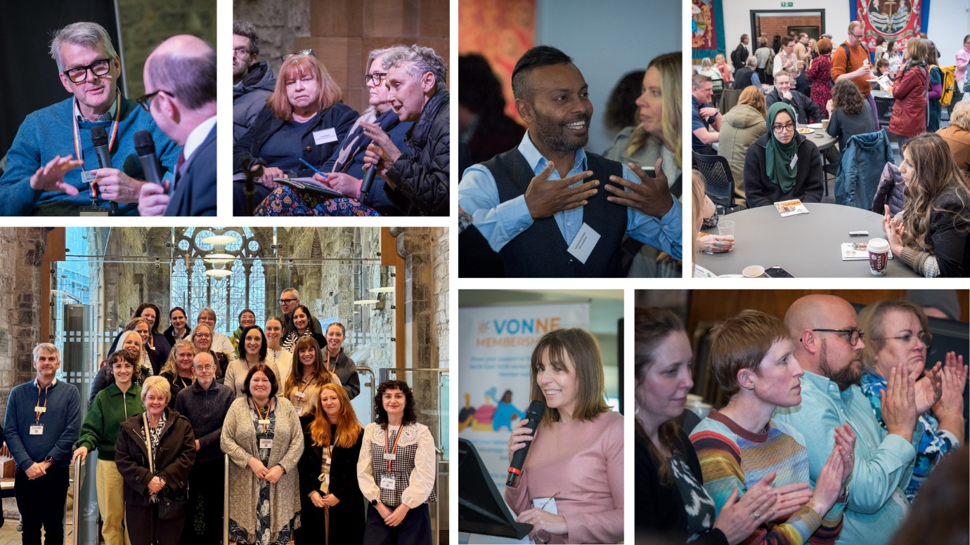

Welcome from VONNE’s Vice Chair

Dear Candidate

Thank you for expressing your interest in the role of Chair of VONNE (Voluntary Organisations’ Network North East).

VONNE is the membership and regional infrastructure body for the voluntary, community and social enterprise (VCSE) sector in the North East of England. We exist to support, promote and advocate for the North East VCSE sector to ensure it’s better understood, supported and appreciated.

- We have over 1,500 members whose experience and need are at the heart of our work.
- VONNE has built a strong reputation of trust and expertise over its 25-year history, during which we’ve developed a wide range of partnerships and strategic relationships to influence policy and practice.
- VONNE is recognised as the go to organisation for knowledge and networking, connecting organisations, people and places across the region to gather and share insight, understand issues and advocate effectively for the North East VCSE sector.
- We have a strong Board of Trustees who collectively bring a wealth of experience and knowledge across the North East.
- We have a committed and experienced staff team.

In line with Charity Commission best practice, and VONNE’s Memorandum and Articles, our current Chair Alison Dunn, is standing down at our next AGM and we’re looking for someone to lead VONNE forward in line with our new Strategy.

Please read the attached information and if you would like to have an informal discussion with me or VONNE’s Chief Executive, Martin Brookes please arrange this through Paula Rosenberg – paula.rosenberg@vonne.org.uk.


We look forward to receiving your application, thank you for your interest in VONNE.

Yours sincerely

Michael Fawole
Vice Chair of VONNE

Who is VONNE?

VONNE (Voluntary Organisations’ Network North East) is the membership and regional infrastructure body for the voluntary, community and social enterprise (VCSE) sector covering the North East of England.

What does VONNE do?
As a membership organisation, VONNE exists to support, promote and advocate for the North East VCSE sector to ensure it’s better understood, supported and appreciated.

How does VONNE do this?
VONNE works to ensure the sector’s voice is heard. Information, networks, and services for members are the key tools. We share all relevant information with members, partners and networks. This includes funders, statutory bodies and policymakers as well as the sector itself.

Why does VONNE do this?
VONNE’s aim is to support the VCSE sector to flourish. This requires the sector to be valued and an equal partner in decision making to create a fairer, greener and successful region. High quality information about, as well as for, the sector, is essential
to achieve this.


Read more about VONNE’s 2026 – 2035 Strategy here.
“VONNE encourages ambition and thinking out of the box, not afraid to lead from the front if that’s what’s required to get something started.”

Meet the VONNE Team

VONNE Board of Trustees
  Alison Dunn  Chair  Society Matters Group |   Michael Fawole  Vice Chair  North East Law Centre |   Craig Henderson  Treasurer  S&W

Adam Hill Sunderland Software City
Angela Brudenell Ability Consultants
Carol Gaskarth PCP
Cheryl Gavin Helix Arts
Colin Hewitt Ward Hadaway
Emma Howitt Teesside Mind
Peter Neal RCVDA
Shaun Newton ELCAP

VONNE Senior Management Team

Martin Brookes
Chief Executive
 |  |  | 
Amy Coates  Head of Comms and Marketing | Angela Goodfellow  Head of Operations | Laura Elliot  Head of Member Services | Lisa Taylor  Health and Wellbeing Programme Director

See the full staff team here.

What our Trustees do
The VONNE Board of Trustees is made up of a maximum of 9 membership elected trustees from full membership organisations and up to 6 co-opted independent trustees appointed by serving Trustees for their particular expertise, qualification and/or knowledge. VONNE’s Board members are Directors of the Company and Trustees of the Charity.
Responsibilities of Board Members:
- Set and maintain VONNE’s vision, mission and values: The Board is responsible for establishing the essential purpose of the organisation and ensures that the objectives, as set out in the Memorandum and Articles of Association, are being met.

- Ensure the continued viability of VONNE: The Board is responsible for making sure sufficient funds are raised to ensure the continued viability of VONNE and ensuring that those funds are properly managed and appropriately accounted for by monitoring, and regularly assessing, the financial position of the organisation.

- Develop VONNE’s strategy and work programme: Together the Board and the Chief Executive Officer and Senior Management Team regularly assess and plan for the long term and strategic development of the organisation. The Board are responsible for setting the overall strategic direction of VONNE’s work programme and agreeing appropriate policies to influence and direct that work.

- Maintain effective Board Performance: The Board will share the governance responsibility for VONNE by attending the AGM and meetings of the Board and participating in sub-committees and working groups. The Board are responsible for feeding any relevant information and views, gathered outside of the organisation, into relevant committee discussions.

- Agree VONNE’s employment procedures: The Board acts as the formal employer of the staff of the organisation and ensures their activities and performance are regularly reviewed and evaluated. The Board creates comprehensive, fair and legal HR procedures. These protect the organisation and those who work for it.

- Ensure VONNE accountability: The Board is responsible for ensuring the organisation meets all its legal responsibilities as a Charity and a Company Limited by Guarantee and does not act illegally or improperly.
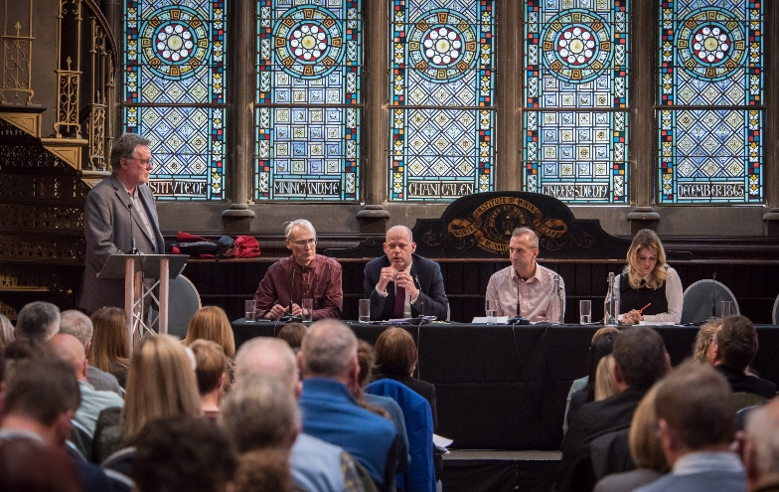
“VONNE takes the sector voice into rooms and networks where it has previously not been heard – well done, that isn’t easy to achieve – keep up the good work.”

Chair of VONNE
The Chair of VONNE leads the Board and works closely with the Chief Executive to provide strategic leadership, champion good governance and support the organisation to achieve its charitable purpose.

What we're looking for
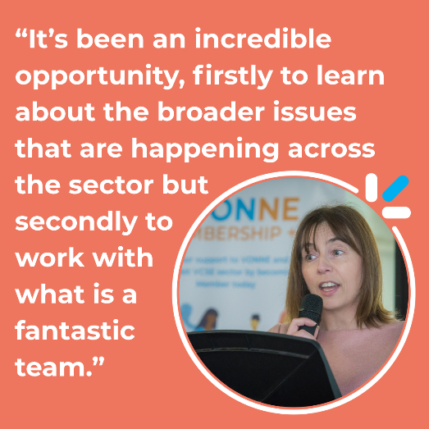
We are looking for an inspiring and well-connected leader who is passionate about the North East and committed to strengthening the VCSE sector across the region. As Chair, you will be a trusted ambassador for VONNE, building relationships, influencing decision-makers and championing the vital contribution of our sector. Working closely with the Chief Executive and Board, you will help guide the organisation through an exciting period of opportunity, ensuring VONNE remains a strong, influential voice for communities across the North East.

Key responsibilities
- Provide strategic leadership to the Board, ensuring effective governance and a clear focus on VONNE's charitable purpose.
- Ensure the Board fulfils its legal and financial responsibilities, maintaining strong oversight of organisational performance, financial sustainability and accountability.
- Chair Board meetings and the Annual General Meeting, setting agendas with the Chief Executive and ensuring effective decision-making and implementation.
- Work in partnership with the Chief Executive to develop and deliver VONNE's strategy, providing support, constructive challenge and accountability.
- Line manage and appraise the Chief Executive on behalf of the Board, supporting their development and wellbeing.
- Foster an inclusive, collaborative and high-performing Board, including supporting trustee recruitment and induction and addressing conflict where required.
- Act as an ambassador for VONNE, building relationships across the voluntary sector and with partners and stakeholders, and representing the organisation externally.

Skills, experience and personal qualities
- A strong commitment to the North East and an understanding of the voluntary, community and social enterprise sector.
- Experience of charity governance and working effectively at Board level.
- Proven strategic leadership with the ability to guide organisations through change and opportunity.
- Strong relationship-building, influencing and ambassadorial skills, with well-developed networks.
- Excellent communication, facilitation and interpersonal skills, with the ability to negotiate, build consensus and make balanced decisions.
- Integrity, impartiality, sound judgement, diplomacy and a commitment to confidentiality.
- A good understanding of VONNE's purpose and the role it plays in supporting the sector.
Strong governance is built on a diversity of voices, experiences and perspectives. We want our Board to reflect the breadth of the North East, so we particularly encourage applications from people who can bring new perspectives, lived experience and strong connections across the region—including Tees Valley and Northumberland, alongside Tyne and Wear—as well as from younger leaders and people from a wide range of socio-economic backgrounds. If you're passionate about the future of our region and believe you can help shape VONNE's next chapter, we'd be delighted to hear from you.

“VONNE is in a period of transformation as Martin and the team enable their vision for the organisation. It’s an exciting time and an opportunity to shape VONNE and its support for the region.”
Alison Dunn, outgoing Chair of Trustees

Time commitment | - There is an expectation that the Chair will regularly meet/support the CEO of VONNE and may represent VONNE at other sector events.  - Attendance at 4-5 Board meetings per year (half a day usually in the afternoon), as well as attendance at VONNE’s AGM and Conference.  - Attendance at 4 Finance and General purposes sub group meetings each year, usually held online.  - Meetings are usually held in Newcastle, the VONNE Conference/AGM is held in different venues throughout the NE.
Remuneration | The role of Chair does not have any financial remuneration; however reasonable out of pocket expenses can be claimed.
Other Officer roles and relationships | - Vice Chair – who will step into the Chair role if required and work closely with the Chair on matters relating to the smooth running of VONNE.  - Treasurer – is responsible for the financial stability of VONNE and will work with the Chair to achieve this.  - Internal relationships – Chief Executive, Senior Management Team, Finance Manager, Management and Governance Support Officer

How to apply
We are committed to inclusive recruitment. Please apply in the format that enables you to best demonstrate your skills and experience. This could be:
- A CV and covering letter (no more than 2 sides of A4 for covering letter)
- A short video or audio submission (no more than 5 minutes please)
- A creative submission, e.g. slide deck or portfolio of engagement work
This should detail why you are interested in the post, how you meet the requirements detailed in the role description, and how you would see the organisation developing. We will ask for references from all shortlisted candidates at a later stage.
Please let us know if you need any reasonable adjustments to enable you to apply for this role and, if shortlisted, attend for interview.
The closing date is 31 July 2026 with interview dates TBC.
Please return completed applications and the form at the end of this document to paula.rosenberg@vonne.org.uk

Recruitment Timetable
Application deadline: 31 July 2026
Interview Dates: TBC
We will always endeavour to contact all applicants following shortlisting.

How we will use your information
We will use your contact details to communicate with you throughout the process and if you become Chair. If successful we will also use your details to comply with reporting requirements for Companies House and the Charity Commission by providing them with your full name, home address, telephone number, email address, nationality, date of birth or other relevant information. Your details will be added to the register of companies on the Companies House website but these require a subscription to access them. Please talk to the Chief Executive if you would like to know more about this. This link provides more information about how VONNE will process your data. Privacy Policy | Voluntary Organisations’ Network North East
Signed …………………………………………..
Date ………………………………………………
Contact us
If you have any questions regarding any of the information in this pack or would like to arrange a meeting with the VONNE Chief Executive Martin Brookes, please contact Paula Rosenberg in the first instance – paula.rosenberg@vonne.org.uk

Application Form and declaration
This form asks for your contact details and information we will need if you become VONNE Chair.
Your details
Full name
Home address
 |  | Postcode
Telephone numbers | Day |  | Evening
 | Mobile
Email address

I am committed to working to achieve the aims of VONNE. I understand the responsibilities and liabilities I am taking on by becoming Chair and agree to devote the necessary time and effort to the role.
I understand that if I am unable to attend three consecutive meetings I may be asked by the Board to resign, as this amount of absence would make it difficult for me to carry out my responsibilities.
I declare that I am not disqualified from acting as a Board Director and that:
- I am aged 16 years or over at the date of this appointment.
- I am capable of managing and administering my own affairs.
- I do not have an unspent conviction relating to any offence involving deception or dishonesty.
- I am not an undischarged bankrupt nor have I made a composition or arrangement with, or granted a trust deed for, my creditors (ignore if discharged from such an arrangement).
- I am not subject to a disqualification order under the Company Directors Disqualification Act 1986 or to an Order made under section 429(b) of the Insolvency Act 1986.
- I have not been removed from the office of charity trustee or trustee for a charity by an Order made by the Charity Commissioners or the High Court on the grounds of any misconduct or mismanagement nor am I subject to an Order under section 7 of the Law Reform (Miscellaneous Provisions) (Scotland) Act 1990, preventing me from being concerned in the management or control of any relevant organisation or body.

