
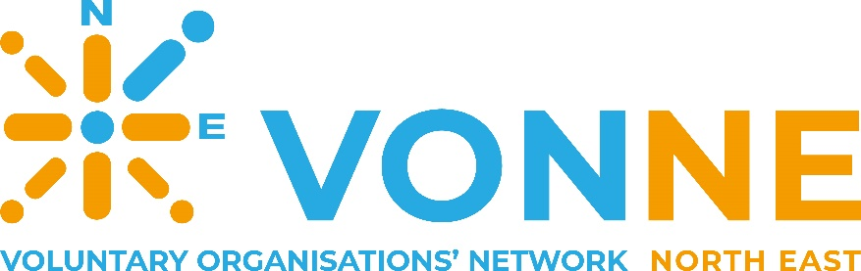

Going Green Together
Project Officer (Maternity Cover)
Candidate Pack
September 2026





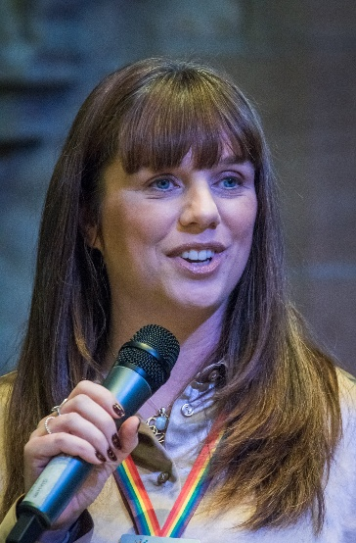
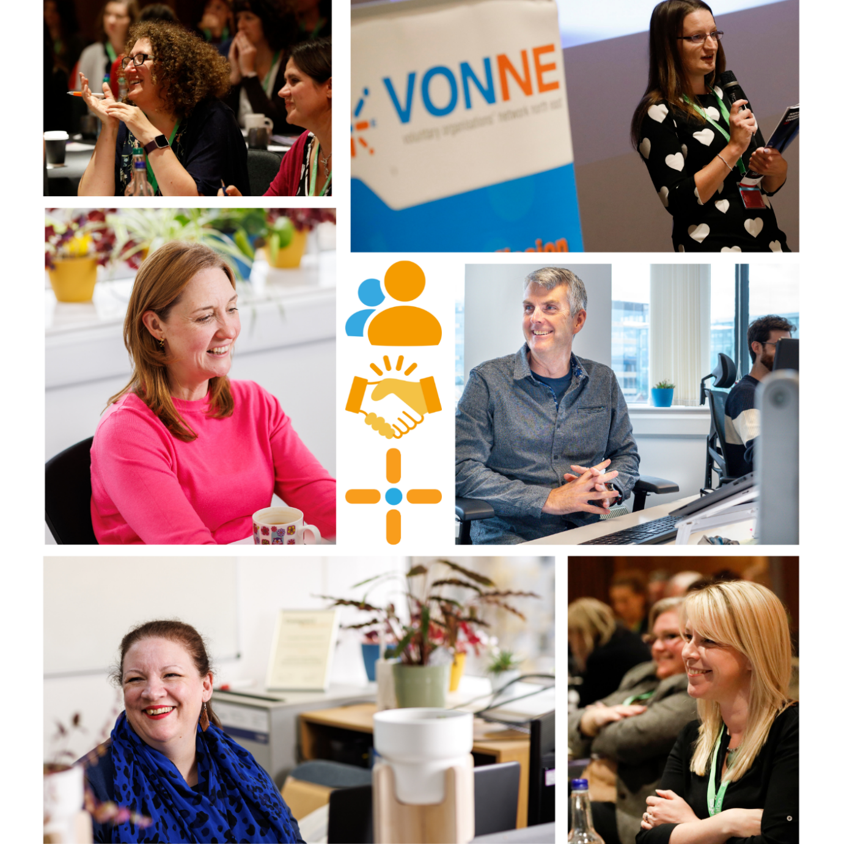

Strengthening the VCSE Sector – Sharing Knowledge – Supporting you

Contents
Welcome 4
About VONNE 5
VONNE’S Mission 6
VONNE’s Strategic Aims 6
History of VONNE 6
Strategic Development 7
Structure 8
Why work for VONNE 8
Job Description 9
Role Summary 9
Responsibilities 9
Person Specification 10
Knowledge, Skill and Expertise 10
Essential criteria 10
Desirable criteria 10
How to apply 11
Recruitment Timetable 11
Principle Terms and Conditions 12
Contact us 13


Welcome

Thank you for your recent interest in the Going Green Together Project Officer role at VONNE (Voluntary Organisations’ Network North East).

VONNE is the North East regional infrastructure organisation supporting, championing and representing the voluntary, community and social enterprise (VCSE) sector across the North East region and promoting social action and economic growth.

- We have over 1,500 members and extensive reach through our subscribers and networks.
- We have a strong Board of Directors who collectively bring a wealth of experience and knowledge across the North East.
- We have a committed and experienced staff team.
- VONNE has built a strong reputation for expertise and quality with funders and stakeholders over its 26-year history.
- VONNE is recognised as the go to organisation for knowledge and networking the VCSE in the region.

We are seeking an enthusiastic, organised, and people-orientated Project Officer that can hit the ground running to support, connect, and empower VCSE organisations on their environmental sustainability journey.

We offer 25 - 28 days holiday plus Bank Holidays (pro rata) plus an extra birthday leave day, a training and personal development allowance, flexible working, healthcare plan, pension, and the opportunity to work in a busy yet supportive environment.

The closing date for applications is Monday 12th October 2026 at 11.59pm, with interviews being held on Wednesday 21st, Thursday 22nd and Friday 23rd of October. Please email any queries and/or your completed application and EDI form to recruitment@vonne.org.uk.

If you would like to discuss the role before applying, please contact Paul Mason at paul.mason@vonne.org.uk .

If you require this pack in an alternative format, please email recruitment@vonne.org.uk.


We welcome applications from all suitably qualified candidates, regardless of their race, gender, disability, religion/belief, sexual orientation or age. Shortlisting is carried out by a team of real people, not AI.
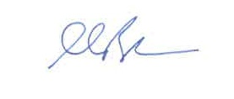

Martin Brookes
Chief Executive

About VONNE

Established in 2000, we have developed and continue to maintain a strong understanding of the needs of the sector and how we can best support organisations through ongoing research and conversations.
Our unique regional position gives us the ability to pilot new projects and approaches to benefit the North East area, often working across sectors with a wide variety of partners. We apply professionalism and knowledge to all the work that we do, and we strive to be a role model for the sector and the region by championing excellence, collaboration and social justice.
Through our work we:
- Share Knowledge.
- Build partnerships and collaboration
- Strengthen the sector
- Give our members a collaborative voice.


VONNE’S Mission
To support the development and sustainability of a strong, effective, and well governed Voluntary, Community and Social Enterprise (VCSE) sector, and promote engagement, involvement and collaboration with the sector as a valued partner.

VONNE’s Strategic Aims
- Support - to support a diverse VCSE sector by providing high-quality services that strengthen capacity, capability and impact.
- Promote – to promote the value and contribution of the VCSE sector to a wide range of audiences.
- Advocate – to advocate for the VCSE sector as a vital partner in shaping policy, strategy and public services.

History of VONNE
VONNE was established as a registered charity and company limited by guarantee in 2000, and it was recognised that the VCSE needed a voice and representation at every level of decision making. VONNE’s region spans 12 unitary authorities, ranging from Berwick in the north to Saltburn in the south, and the Pennines in the west.

VONNE has remained both relevant and much needed throughout the ever-shifting picture of sub regional and regional arms of government and has grown in strength, adapting to the new policy environment in which it operates.

VONNE is an expert on the sector in the North East and is a credible presence, continuing to attract funding and generate new revenue streams that are aligned to our mission enabling us to maintain a healthy reserves position.

VONNE's profile is high, and our reputation remains solid both within and beyond the North East region. Information to the sector has been of a consistently high standard and VONNE's advocacy work, intelligence, and expertise on behalf of the sector continue to be well regarded.

Strategic Development
Following a period of rapid organisational growth and change, VONNE refreshed and released our strategy for 2026 – 2031 placing greater emphasis on our core purpose of supporting, promoting and advocating for the North East VCSE sector.

As a membership organisation, we’ll be focussing more directly on putting member voices, experiences and needs at the heart of our work. This will see us develop greater cohesion across our work streams, including building stronger connection between policy, membership and communication – the core of our work.

Read our strategy here.


“VONNE encourages ambition and thinking out of the box, we are not afraid to lead from the front if that’s what’s required to get something started.”



Structure

In recent years we have been successful in developing and securing funding for a number of new multi-year strategic projects. In early 2022, after 2 years of significant growth, we undertook an organisational restructure to establish three core teams – Operations, Members Services and Projects and Partnerships. More recently, as part of our strategy review we created an additional Communications and Marketing team and Policy and Data team. This has enabled us to recruit additional staff and ensure adequate staff capacity across the various functions of the organisation.
You can see our VONNE Staff Structure 2025.pptx.

Why work for VONNE

VONNE is a great place to work. We have a fantastic team of highly skilled, knowledgeable and kind people, who are passionate about the work they do.
We have a welcoming and supportive environment, and you will be a valued member of the team, where your views and opinions will be encouraged and welcomed, we work together to achieve our goals, have a strong mission and positive values.
VONNE offers lots of staff benefits including:
Hybrid and flexible working, up to 28 days annual leave plus Bank Holidays AND the period between Christmas and New Year, a day off on your birthday, access to Simply Health to cover costs of everyday healthcare such as prescriptions, visits to the dentist, opticians, GP appointments, etc.
A training and development allowance, refreshed annually to support your career development and a small amount each year to support your personal development to either undertake a course or activity that will broaden skills or knowledge, or that is designed to increase self-esteem or self-confidence and support overall wellbeing.
We have a focus on health and wellbeing and discuss this regularly through supervisions.
Further benefits include a clear salary scale so you can progress each year, and a 5% employer contribution to our pension scheme. We offer a travel scheme so you can spread the cost of commuting across the year, and a Cycle to Work scheme which will support you to buy a bike, plus several other benefits.

Job Description
Job title Going Green Together Project Officer (Maternity Cover – 11 Months)
Reporting to Project Coordinator
Salary £29,542 - £30,515 pro-rata (NJC scale 12-14)
Days worked Part-time - 3 days per week (22.2 hours)

Summary
The Going Green Together Project Officer plays a key role in the delivery, promotion, and ongoing development of the Going Green Together programme across the North East. Working closely with delivery partners, stakeholders, and participating VCSE organisations, the postholder coordinates and delivers a range of project activities including one-to-one organisational support, communications and marketing, events, resource development, monitoring and evaluation, and partnership engagement. The role is responsible for building strong sector relationships, supporting collaborative working, and ensuring the project effectively engages, informs, and empowers organisations to progress their environmental sustainability goals while contributing to the overall success and impact of the programme.

Key Responsibilities
- Build relationships with key stakeholders and be a positive ambassador for the project and VONNE across the region
- Deliver one to one support for project participants
- Working with key partners to coordinate programme delivery and activities
- Support and deliver project communications and marketing strategy, working closely with the project communications consultant
- Promotion of the project and support the offer to VCSE organisations across the North East
- Support with developing relationships with key partners and facilitate the relaunch of the VONNE Climate Action Alliance
- Development and delivery of the events programme
- Contribute to the production of toolkits and resources
- Maintain the Going Green Together website, working closely with delivery partners
- Support and contribute to then monitoring and evaluation of the project
- Deliver blog posts and monthly newsletter

Person Specification

Essential criteria:
  - Experience of delivering support and/or training opportunities.
  - Strong interpersonal and written communication skills.
  - Strong digital skills, including use of social media and Microsoft programmes including Excel.
  - Well-organised, with confidence in data-based and administrative tasks.
  - Experience of the voluntary, community, and social enterprise sector, for instance through volunteering or previously working for a charity or community group.
  - The role is regional and therefore requires the ability to travel across the North East and North Cumbria regions on occasion.

Desirable criteria:
  - Previous project officer experience within the voluntary, community, and social enterprise sector.
  - Experience of website maintenance and the production of newsletters.
  - Experience of working in a partnership-based project structure.
  - Experience of, or accreditation in, environmental sustainability and climate action.
  - Experience of monitoring and evaluation processes.

How to apply
We are committed to inclusive recruitment. Please apply in the format that enables you to best demonstrate your skills and experience. This could be:
- A CV and covering letter (no more than 2 sides of A4 for covering letter)
- A short video or audio submission (no more than 5 minutes please)
- A creative submission, e.g. slide deck or portfolio of engagement work
Please include in your submission your contact details and why you’re applying for this position. Highlight why you’re particularly suited to the role, remembering to cover the points in the person specification.
Please email any queries and/or your completed application and EDI form to recruitment@vonne.org.uk.

Recruitment Timetable
Application deadline: Monday 12th October 2026 at 11.59pm

Interview Dates: Wednesday 21st, Thursday 22nd and Friday 23rd October 2026 (in person)

We will always endeavour to contact all applicants following shortlisting. Shortlisting is carried out by our panels of experts. We do not use AI.


Principle Terms and Conditions

Responsible to Going Green Together Project Coordinator
Hours worked Three days per week (22.5 hours). Working days to be agreed. Usual working hours are Monday to Friday, 9am to 5pm. However, we operate a flexible system to allow for working patterns outside these hours to be accommodated, with agreement, according to need.

Salary NJC Salary Scale 12 to 14 (£29,542 to £30,515). Standard of living increases will be awarded each year in line with local authority pay settlements. Following the probation period, salary scale increments will be awarded annually.

Contract Maternity Cover, fixed term for 11 months.

Notice Notice to terminate employment is 1 month by either side (one week during the probationary period).

Annual leave The full-time entitlement is 25 days plus Bank Holidays and the period between Christmas and New Year. Annual leave increases to 28 days with annual increments of one day for each full year of continuous service.

Pension VONNE’s pension provider is The People’s Pension and VONNE is prepared to make an employer contribution to this or the post holder’s personal pension scheme of 5% of salary, provided the staff member makes at least the minimum contribution as per auto-enrolment.

Location Home working predominantly with the option to work from various co-working locations. The role will also require the ability to travel across the North East to meet with Going Green Together participants and delivery partners, and to attend events.

Expenses VONNE will pay for travel and subsistence if an employee is requested to travel as part of their role (outside of commuting to work).

Health VONNE staff are covered by the Simply Health Cash Plan scheme, through which employees can claim for visits to an optician, physiotherapist, chiropodist, emergency care from the dentist and more.

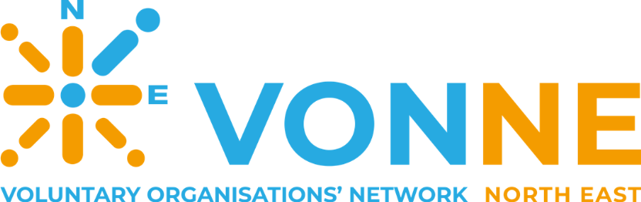

Contact us

0191 233 2000

vonne@vonne.org.uk

www.vonne.org.uk

