Third Sector Trends in North East England 2022

What is the study about?
Third Sector Trends is the longest running study of the voluntary, community and social enterprise (VCSE) sector in the UK. In North East England, where the study began, baseline studies were completed in 2008. Regular surveys have taken place since 2010. The study collected well over 3,250 responses across the North of England in 2019.
Third Sector Trends complements Charity Commission, NCVO Civil Society Almanac and 360Giving data to produce robust estimates on employment, volunteering, sector finance and assets. The study then looks at how the ‘energy’ the sector has at its disposal is applied to local causes.
Even though this is a large-scale study, its principal purpose is to study the structure, dynamics and impact of the ‘local’ VCSE sector. Only by looking at several areas, is it possible to understand individual localities properly.
Over the years, study has been supported by a range of funders including Community Foundation Tyne & Wear and Northumberland, Northern Rock Foundation, Millfield House Foundation, Garfield Weston, Joseph Rowntree Foundation, Power to Change, Charity Bank, Barrow Cadbury Trust Sport England together with several local authorities, combined authorities and the NHS.
Third Sector Trends is independent and impartial. As such it aims to provide objective interpretation of rigorously collected data to serve the interests of the voluntary sector, local public and health sector, the Lottery, charitable trusts and foundations and businesses.

What evidence does the study collect?
The survey has a core set of questions which never change to ensure comparability. But in each round of the research, there is space to explore contemporary issues. The 2022 survey has, for example, specific focus on the following issues:
- The extent to which the Covid pandemic has reshaped and refocused VCSE sector activity.
- The positive role the VCSE sector can play in ‘levelling up’, ‘localism’ and ‘community wealth building’ agendas.
- The contribution the VCSE sector can make to public health and, specifically, healthy life expectancy.
- How the VCSE helps to secure economic and social wellbeing in localities.

How are the findings used?
The study is widely used by local authorities, combined authorities, NHS partnerships and VCSE infrastructure organisations in their strategic work and policy formulation. For an example of the full set of findings from the 2019 study at a regional level, see this report:
https://www.communityfoundation.org.uk/wordpress/wp-content/uploads/2020/05/THIRD-SECTOR-TRENDS-IN-NORTH-EAST-ENGLAND-2020-1-1.pdf
Data are also used for more in-depth work, for example, recent work in Yorkshire & Humber to show how much energy the sector has, where it focuses its activities and how much impact it achieved.
The difference the third sector makes - St Chad's College Durham (stchads.ac.uk) and The contribution of the VCSE sector to health and wellbeing in Humber, Coast and Vale - St Chad's College Durham (stchads.ac.uk),
Data have also been used in Cornwall and Isles of Scilly to assess the strengths of the VCSE sector to support the development of strategies to align sector activity with NHS England priorities for Integrated Care Systems. The first of a series of reports can be found here:
Voluntary sector dynamics in Cornwall and Isles of Scilly - St Chad's College Durham (stchads.ac.uk)
It has also been possible to do in-depth work on aspects of sector structure and activity which has previously been neglected. Including, for example, issues associated with diversity in sector leadership:
Diversity and inclusion in Third Sector leadership: why is it not happening? - St Chad's College Durham (stchads.ac.uk)
and how the VCSE sector works with the private sector:
Going the extra mile, how business supports charities - St Chad's College Durham (stchads.ac.uk)

To start the survey clink this link: Join the Third Sector Trends survey here
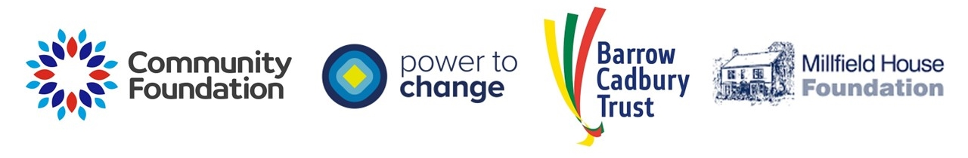For further information, please contact Professor Tony Chapman, Director of Policy&Practice, St Chad’s College, Durham University, Email: tony.chapman@durham.ac.uk.
To get access to all the study’s reports, visit this website: Third sector trends research | Community Foundation

